Midterm Exam

HSE 207: Engineering Mechanics

**Solutions**

By Seungchul Lee

**Problem 1 (5 points)**

* Linear translation motion can be considered as a circular motion with the very large radius.
* Linear combination of circular motions can generate many different motions such as linear translation, ellipsoid, etc.

**Problem 2 (10 points)**

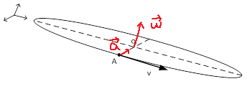

Figure 1

**Problem 3 (5 points)**

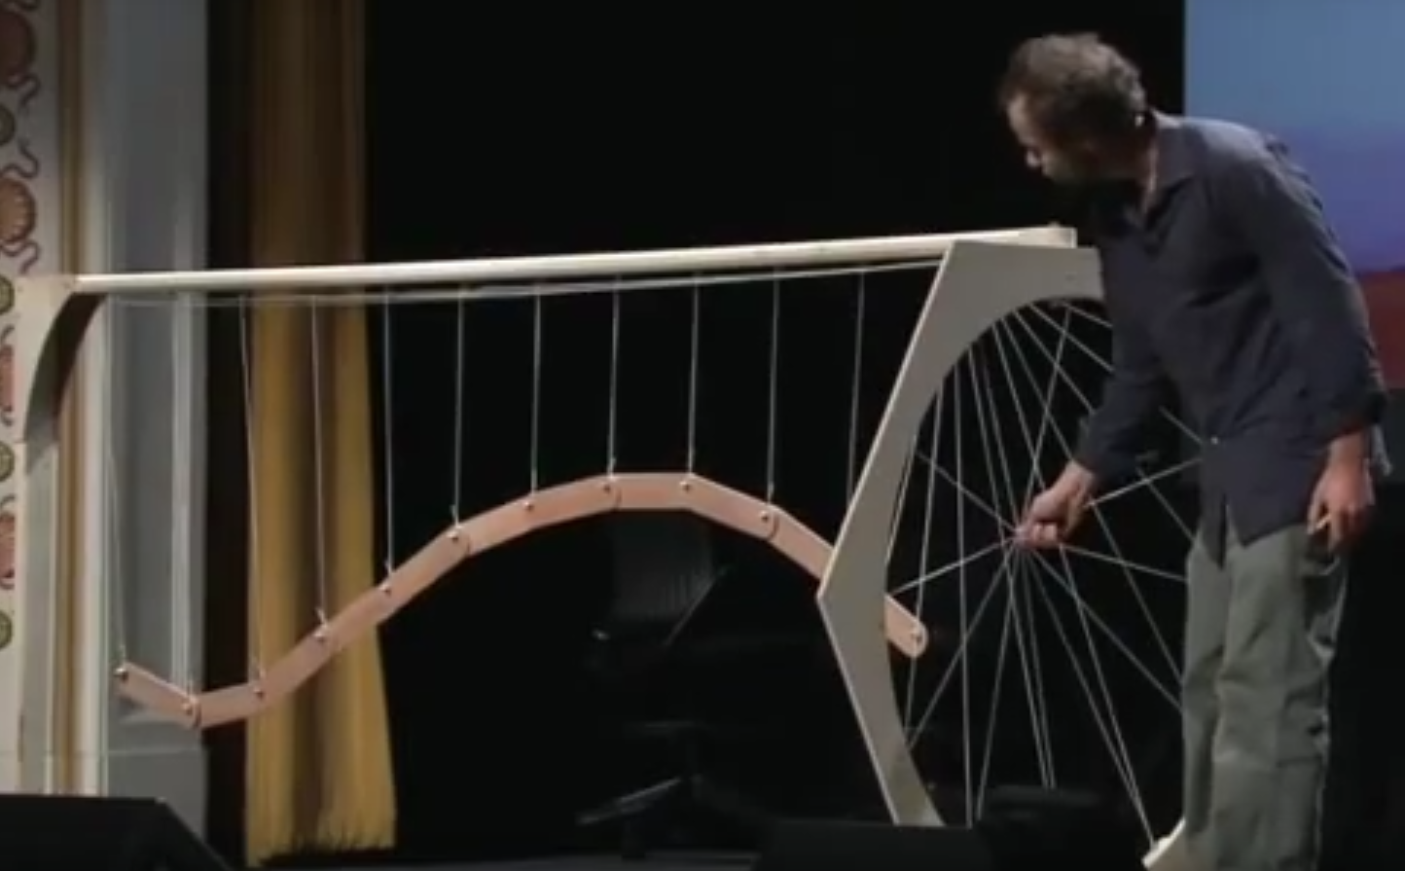

**Problem 4 (10 points)**

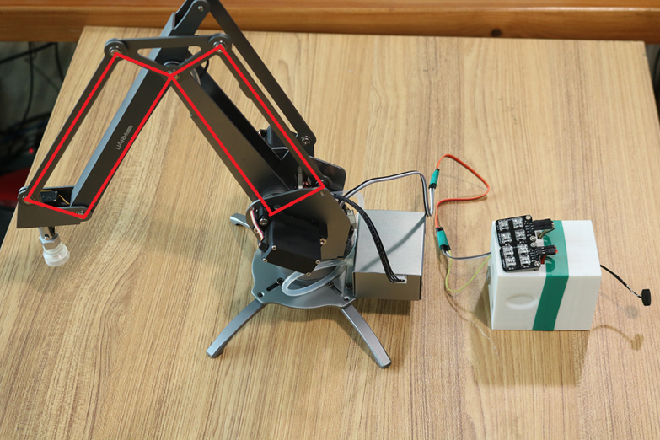

**Problem 5 (5 points)**

There are many cylinders in a car engine.

**Problem 6 (10 points)**

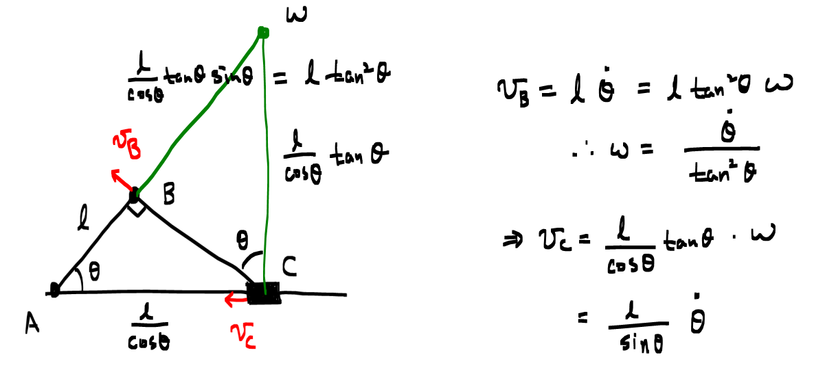

**Problem 7 (10 points)**



**Problem 8 (10 points)**

1) Inertia reference frame

2) Non-inertia reference frame

**Problem 9 (10 points)**

The same length = 0.1 m

**Problem 10 (5 points)**

Zero

**Problem 11 (10 points)**

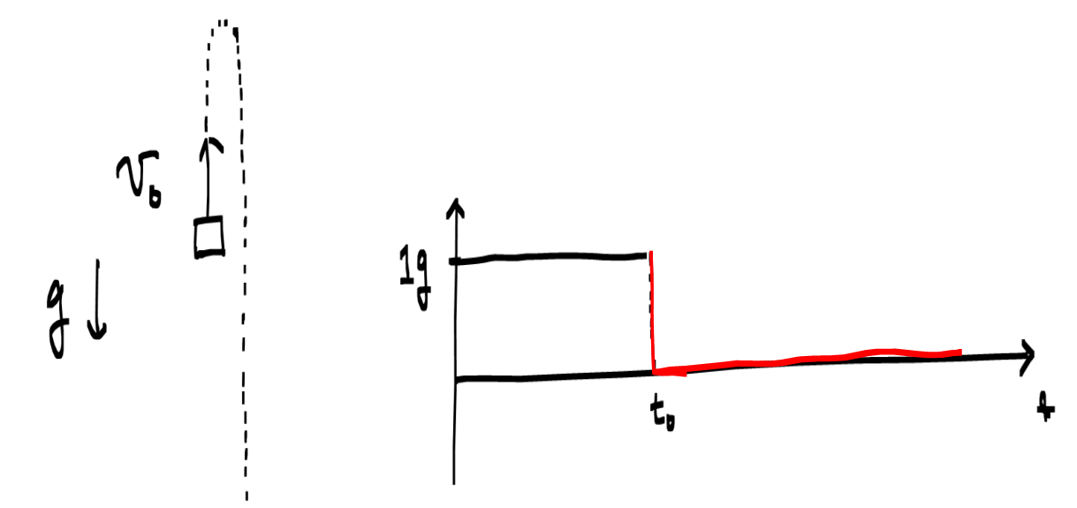

**Problem 12 (20 points)**

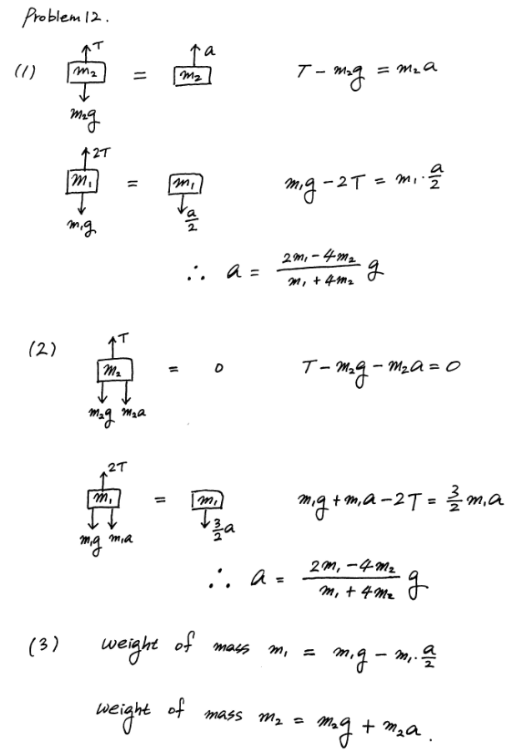

**Problem 13 (20 points)**

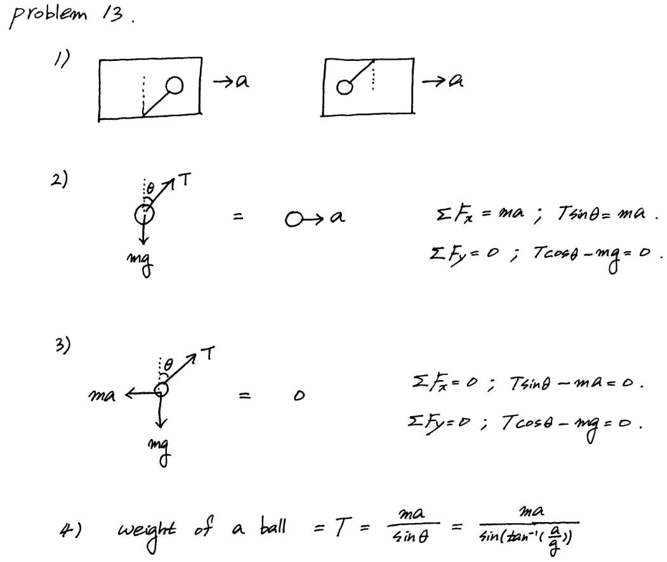

**Problem 14 (10 points)**

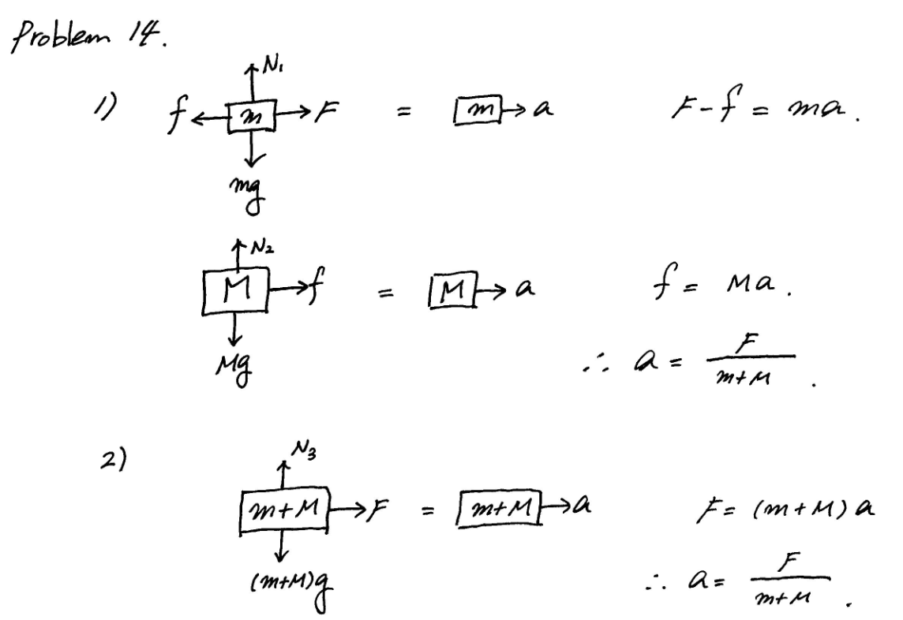

**Problem 15 (20 points)**

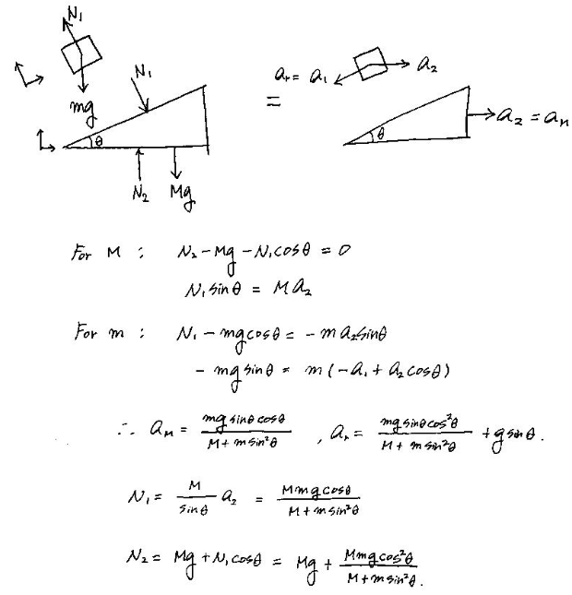

**Problem 16 (20 points)**

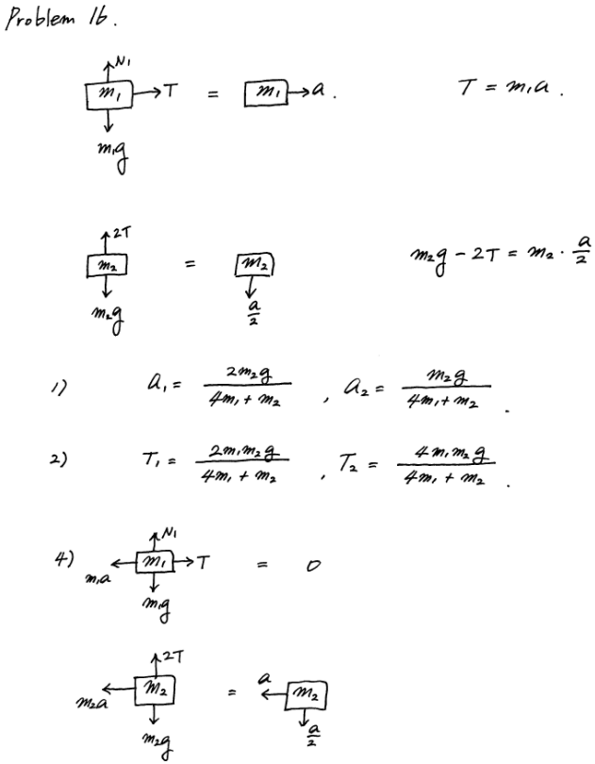

**Problem 17 (10 points)**

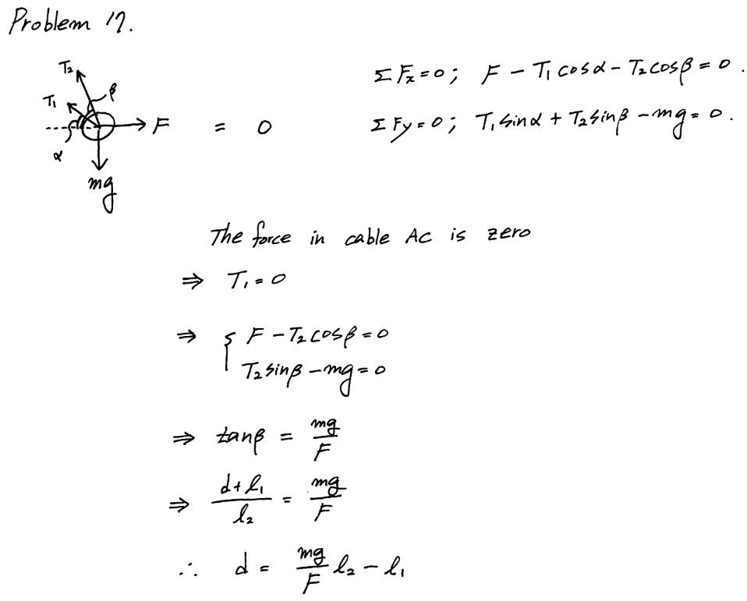

**Problem 18 (10 points)**

1) Bicycle transition between public bicycle stations

2) Daejeon

3) Bicycle stations which have higher utilization, bicycle path that are often used by users, etc.

4) Which station has higher priority when more bicycles are allocated?